EXPERIMENT-4

4.A GPS navigation system selects the next city based on the estimated distance to the destination. Implement Best First Search Algorithm. Find a path using heuristic evaluation.

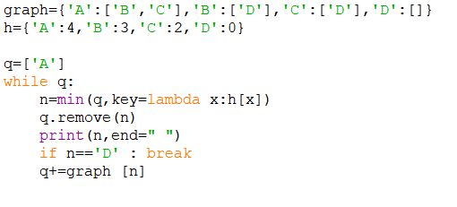
PROGRAM SCREENSHOT:

OUTCOME SCREENSHOT:


